**Project Design Phase-II**

**Data Flow Diagram & User Stories**

|  |  |
| --- | --- |
| Date | 9th October 2023 |
| Team ID | PNT2023TMID592830 |
| Project Name | Project – Travel Insurance Prediction |
| Maximum Marks | 4 Marks |

**Data Flow Diagrams:**

A Data Flow Diagram (DFD) is a traditional visual representation of the information flows within a system. A neat and clear DFD can depict the right amount of the system requirement graphically. It shows how data enters and leaves the system, what changes the information, and where data is stored.

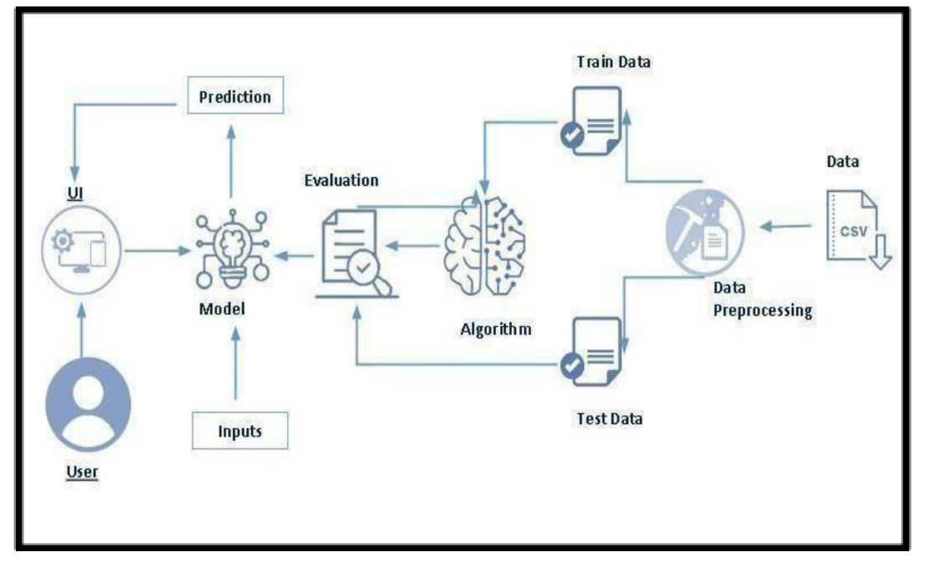

**Example:** [**(Simplified)**](https://developer.ibm.com/patterns/visualize-unstructured-text/)



As we can see here we would have to go and input the values of Age, Employment Type, Annual Income, Family Members, Chronic Diseases, Frequent Flyer, Ever Travelled broad, after which the user would have to submit which would result in the output of the required answer.  
Since the flow of the above is direct and would only result in no value if nothing is entered in the text box provided this is pretty much it.

**User Stories**

Use the below template to list all the user stories for the product.

|  |  |  |  |  |  |  |
| --- | --- | --- | --- | --- | --- | --- |
| **User Type** | **Functional**  **Requirement (Epic)** | **User Story**  **Number** | **User Story / Task** | **Acceptance criteria** | **Priority** | **Release** |
| Customer (Web  User) | Dashboard | USN-1 | As the user inputs all the values and clicks submit the result is a white page showing some error. | Dashboard can be accessed. | High | Sprint-1 |
|  |  | USN-2 | Same issues is being followed. | Dashboard can be accessed. | High | Sprint-2 |
| Customer Care Executive | Dashboard | USN - 1 | The Task is to inform the customer that the issue would be resolved asap and continue. | .. | Very High | Sprint - 1 |
| Tech Dev |  |  | Resolves the issue. |  |  |  |